# LED_PI Prototyp

Lüsterklemme:

Rechts: VCC

Links: GND

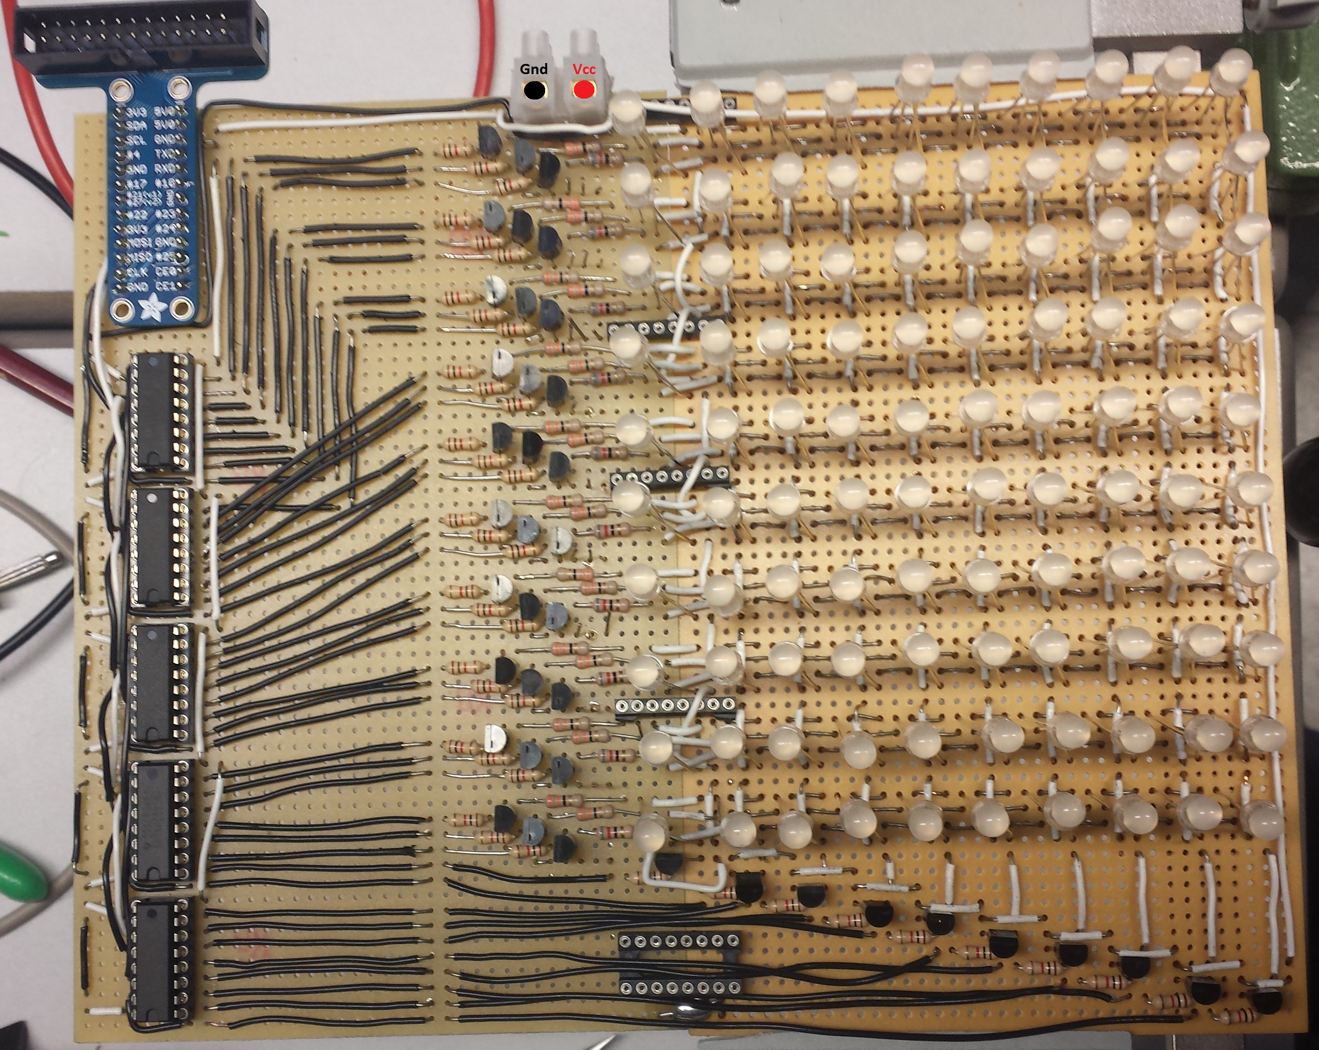

PINS:

STCP GPIO_11

SHCP GPIO_09

DS GPIO_10

Matrix: 10x10

COL_OFFSET 0

ROW_OFFSET 30